Chess project and game throughout Tyršova Primary School

Address
Kuldova 38, Brno-Židenice, 61500
Contents:
Brief annotation 3
Financial balance sheet 4
Time schedule 5
Number of students involved 6
The contribution of teachers 7
Project realisation 8
Detailed presentation of the chess part 8
Detailed presentation of the encryption game part 13
Theoretical basis 17
Project benefits 18
Project summary 20

Brief annotation
As part of the DIgiMe project, our school decided to divide the project into two parts, while the equipment used was mixed into both parts of the project. The main part of the project is the production of chess and a chessboard on a 3D printer. The chess "packaging" includes, in addition to the figures, which are displayed as busts with the faces of pupils and teachers of Tyršová ZŠ, a chessboard, a tutorial with the moves of the pieces and a booklet where the individual pieces are introduced. The second part of the project consists of an interactive encryption game for pupils around the school building, which is also a national cultural monument. This encryption game makes an imaginary "guide" around the building out of students of the 1st and 2nd grade and thus helps the students to recognize the beauty of functionalist architecture and through individual tasks repeat the knowledge from some subjects.

Financial balance sheet
SL1 set | 1 | 51 980,00 CZK | https://shop.prusa3d.com/en/3d-printers/721-original-prusa-sl1-3d-printer-curing-and-washing-machine.html
White resin | 1 | 1 499,00 CZK | https://shop.prusa3d.com/cs/resiny/944-bila-pryskyrice-tvrda-1kg.html
Black resin | 1 | 1 499,00 CZK | https://shop.prusa3d.com/cs/resiny/943-cerna-pryskyrice-tvrda-1kg.html
PLA White | 2 | 1 200,00 CZK | https://shop.prusa3d.com/en/filament/171-pla-extrafill-traffic-white-750g.html
PLA Black | 2 | 1 200,00 CZK | https://shop.prusa3d.com/en/prusament/959-prusament-pla-jet-black-1kg.html
BlueCast Phrozen | 1 | 2 290,00 CZK | https://shop.prusa3d.com/cs/resiny/985-bluecast-phrozen-wax-casting-resin-05kg.html
Flashforge Adventurer 3 | 1 | 13 058,22 CZK | https://www.conrad.cz/3d-tiskarna-flashforge-adventurer-3.k1998367
Isopropyl alcohol | 2 | 377,00 CZK | https://www.energieprofis.cz/isopropylalkohol-isopropanol-99-9-1-litr
LEGO Education | 1 | 11 499,00 CZK | https://www.kitstore.cz/p/lego-education-45544-ev3-zakladni-souprava
Lego sensor | 1 | 1 100,00 CZK | http://www.stavebniceprochytredeti.cz/cs/lego-education-45509-ev3-ir-senzor-679.html
Nozzles | 1 | 399,00 CZK | http://www.jprint3d.cz/e-shop/dily-reprap-prusa-i3/tryska-set-9ks-pro-3d-tiskarny-reprap?zobrazit-zbozi=369
Resins | 2 | 2 998,00 CZK | https://shop.prusa3d.com/cs/resiny/1001-transparentni-zelena-pryskyrice-tvrda-1kg.html
Resins | 2 | 2 998,00 CZK | https://shop.prusa3d.com/cs/resiny/939-transparentni-cervena-pryskyrice-tvrda-1kg.html
Resins | 1 | 1 499,00 CZK | https://shop.prusa3d.com/cs/resiny/945-transparentni-pryskyrice-tvrda-1kg.html
Foil | 3 | 1 197,00 CZK | https://shop.prusa3d.com/cs/sl1-prislusenstvi/1201-fep-folie-3-kusy.html?search_query=folie&results=2
Filament | 3 | 1 041,00 CZK | https://www.abc3d.cz/eshop/fillamentum-pla-detail#9428
 | 3 | 1 041,00 CZK | https://www.abc3d.cz/eshop/fillamentum-pla-detail#9407
 | 3 | 1 041,00 CZK | https://www.abc3d.cz/eshop/fillamentum-pla-detail#9425
Washer | 1 | 463,00 CZK | https://www.abc3d.cz/eshop/platform-assembly-extractable-adventurer3-detail
Total price: 99 268,22 CZK

Time schedule
Originally, the project was based on a schedule that was set at the beginning. That means the school years 2019/2020-2020/2021 school year. Unfortunately, there were some unexpected changes along the way. The first change was a personnel change in the pedagogical leadership. Since a colleague Mgr. Pavel Mrnuštík changed his place of work, replacing him with Mgr. Mariana Čepila and Mgr. Jan Krajčirovič. Furthermore, the situation with the project was crossed by the pandemic of COVID19. The closure of the schools meant that we could only complete the first half of the project, i.e. chess project. Pupils could also partially work on the chess project at home. As soon as it was possible, we worked with the pupils at least in the form of consultations at the school. But the problem was that a number of teachers were absent from the school due to the quarantine, so the final photography and creation of the 3D model was delayed. The last major problem we had to deal with were changes in the student team. These changes were caused by the extension of the project to the first half of the 2021/2022 school year. The key part of the team was made up of pupils (a total of 5 pupils) who finished the ninth grade in the 2020/2021 school year and went to secondary schools, so we had to change the teams and introduce new pupils to the issue. Despite all these complications, we finally managed everything successfully and were able to implement at least a large part of the project. We plan to complete the second part after the deadline, probably at the end of the first semester of the 2021/2022 school year.

Number of students involved
Gradually, almost two dozen students took turns in the project. This large number was due to the fact that, as already mentioned above, some students left the seventh grade when they started the project for six-year high schools, a larger number then left for secondary schools from the ninth grade, some students also had to leave the project due to their extracurricular activities . Namely, the following took turns in the project: Anna Berenika Standarová, Eliška Šafářová, Jáchym Kolář, Anna Ondroušková, Jan Brabec, Martin Šlegl, Vít Holík, Martin Kubáň, Tomáš Mährischl, Vanessa Kubátová, Andrea Nedvědová, Silvie Kozlíková, Terezie Vondrušková and Karolína Paulová.
Individual students participated in the following parts of the project:
Chess:
Photography of teachers, interviews with teachers and video tutorial: Silvie Kozlíková, Terezie Vondrušková, Karolína Paulová
Booklet text, typesetting and creation: Martin Šlegl, Eliška Šafářová, Jáchym Kolář
Creating a 3D model: Anna Ondroušková
Encryption Game:
Libretto: Anna Berenika Standarová, Jan Brabec
Location and photography of places in the school: Vanessa Kubátová, Andrea Nedvědová, Tomáš Mährischl
Questions and encryption system: Vanessa Kubátová, Andrea Nedvědová, Tomáš Mährischl, Vít Holík, Martin Kubáň
Construction and programming of the robot: Vít Holík and Martin Kubáň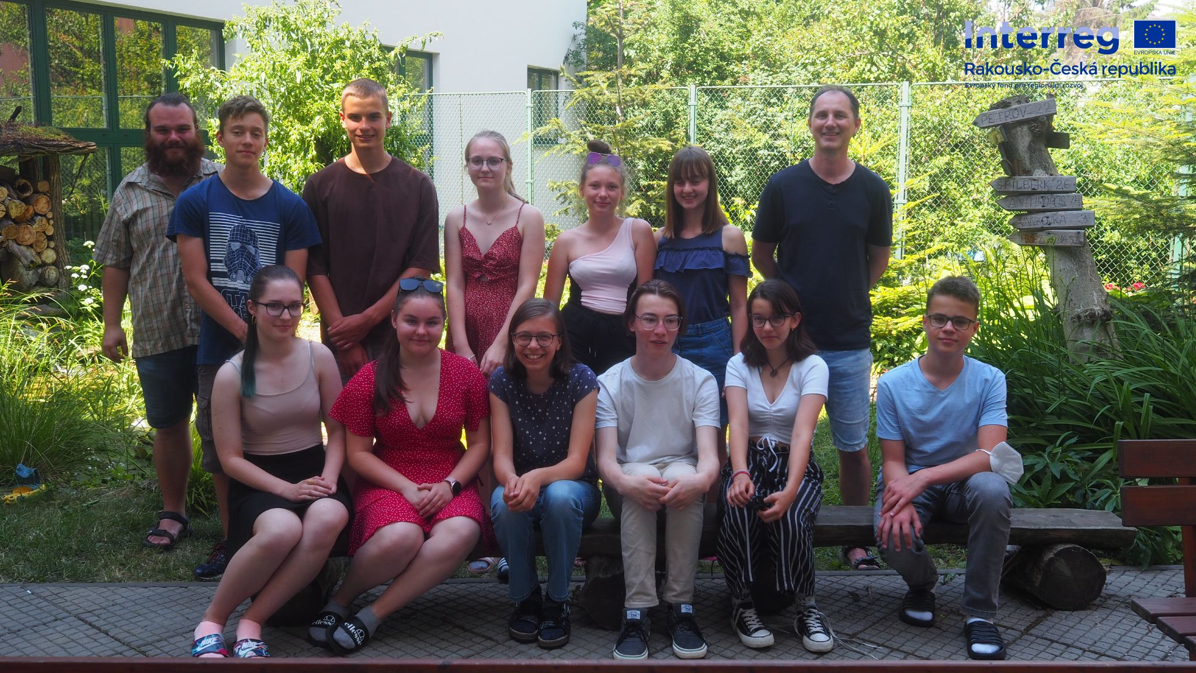

The contribution of teachers
M.Sc. Marian Čepil was the leading teacher in the entire project.He was not only in charge of the administrative side, but above all he solved the problem of programming the robot with the students involved, he also solved the creation of the model and the acquisition of photographic material for the creation of a 3D model with the students. Since the 3D printer was located in the computer science classroom, it was him who monitored the successful progress of the 3D printing with the students. In addition to his professional contribution during the entire project, he also monitored whether the project was continuously documented and whether the materials were clear and accessible to all pupils.
M.Sc. Pavel Mrnuštík participated in the project in the first school year. together with Mgr. Marian Čepil, he helped the pupils to come up with the entire concept of the project. In the first part, he was primarily responsible for the team of pupils who participated in the game throughout school. But he also took part in solving the issue of 3D printing and programming.
M.Sc. Jan Krajčirovič participated in the creation of the chess manual. He continuously consulted with the pupils, the literary part of the description for the individual figures and the typesetting of the text itself. He then took over the part of organising the game throughout the school game from Mgr. Pavlo Mrnuštík. He was an asset in the project, especially in matters of the school's history. He also participated with the pupils in the conception of the reward system and procedures in the game.

Project realisation

Detailed presentation of the chess part
The goal of this part: The goal of the main part of the chess project was to create chess pieces, which were conceived as busts with portraits of students and teachers, a video tutorial and a brochure.
Chess pieces: The chess pieces themselves were created using 3D printing technology on the Original Prusa SL1 printer using colored, transparent resins. At the beginning, the students planned which of the teachers would be which figure. This part was quite challenging, mainly because each chess piece carries a certain symbolism, so it was necessary to carefully consider which piece would represent which teacher. After this balance, the actual work on the figurines began. This work was carried out in the following sub-steps: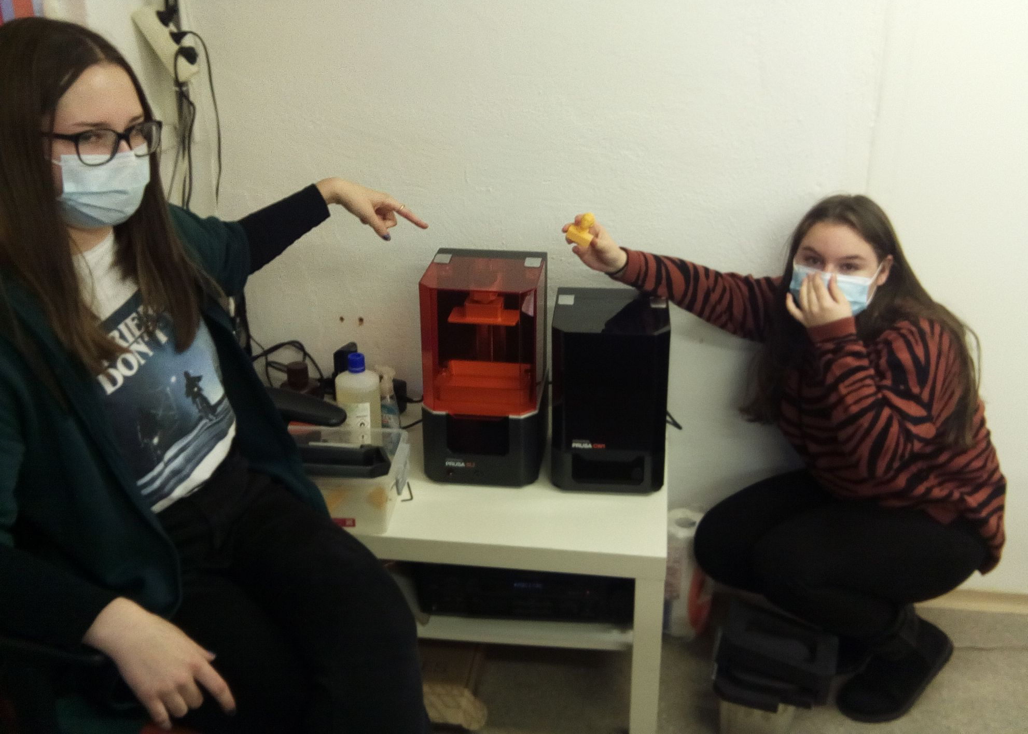
- photogrammetry: over the course of less than a year, students gradually photographed individual teachers and students in detail, so that there were enough photos to create a 3D model. In this phase, the students mainly struggled with the problems of combining all the photos into a 3D model. Among the biggest obstacles was solving the problems caused by e.g. glasses, long hair, hairstyle, facial expression, etc. when taking photos.

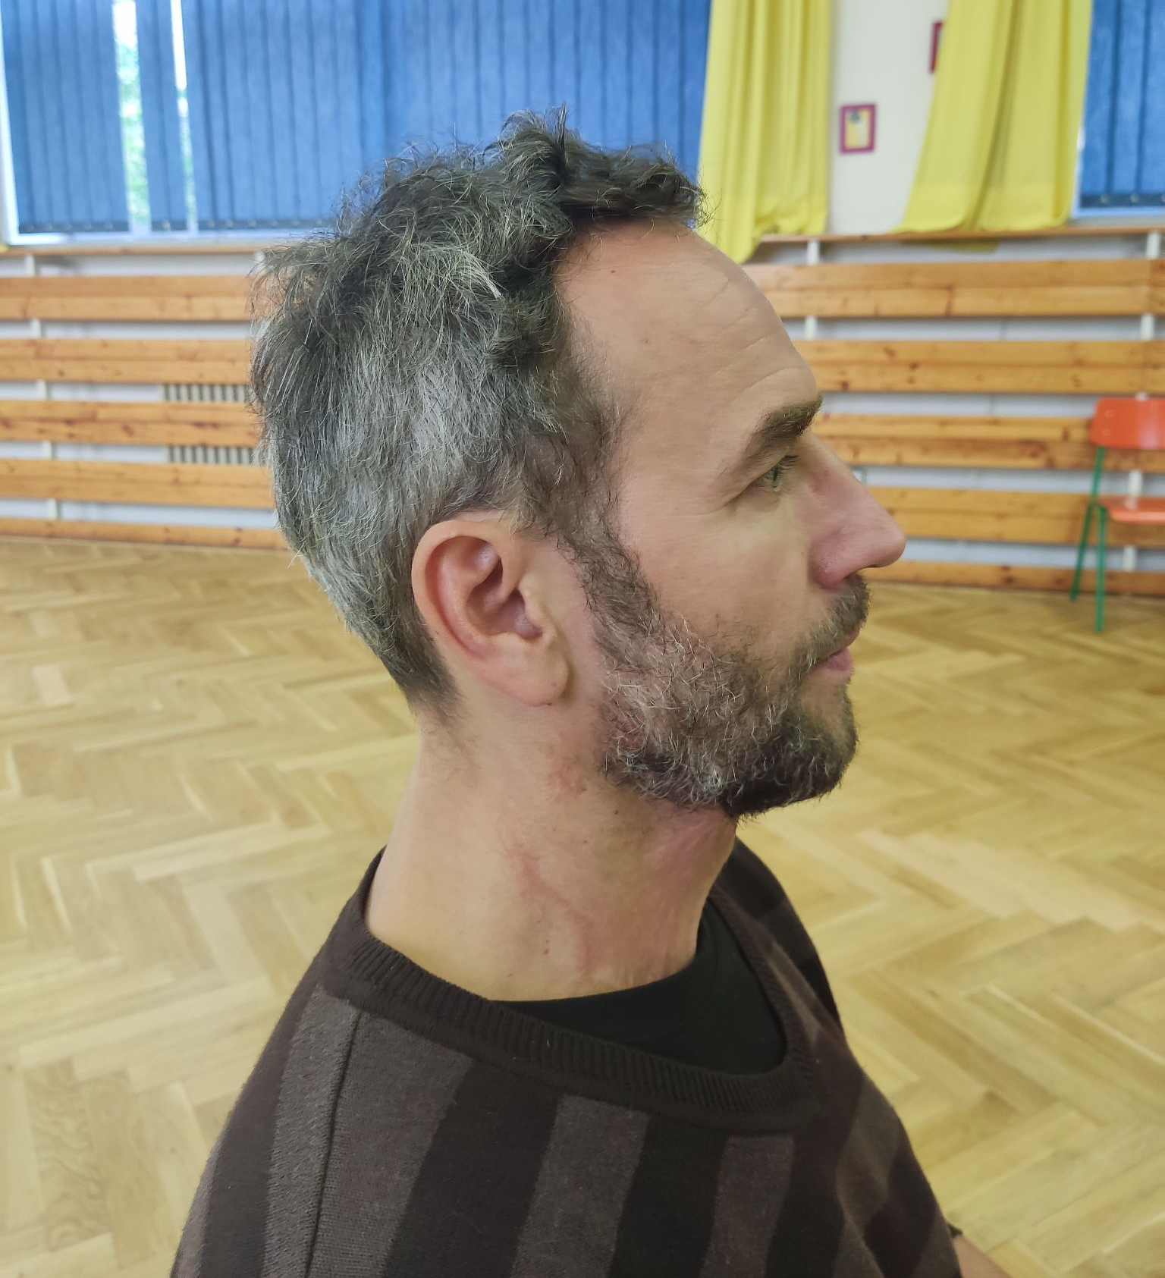
- creation of the final 3D model: After obtaining sufficient material, the photos were converted into a 3D model. For this, we tested several programs with different results. The 3D program Zephyr Free https://www.3dflow.net/3df-zephyr-free/. has proven itself to be the most suitable. This program took several hours to process individual models, some failed after completion and we had to recreate the set of photos. Then came the actual modelling of the figures. First, we edited the model using the Blender program in which we smoothed and cropped the models. After that, it was necessary to obtain a 3D model of the original chess pieces and, above all, to solve the problem of how to fit the faces of students and teachers on the known base of the pieces and on the key attributes of the pieces that everyone knows from ordinary chess, so that one or the other is not at the expense of recognizability. For this purpose, we used the software that came in with the FlashForge printer – Flashprint https://www.flashforge.com/download-center , which helped us with cutting and disassembling the individual parts of the figure. We used the default settings of the printers when printing both the pieces and the chessboard.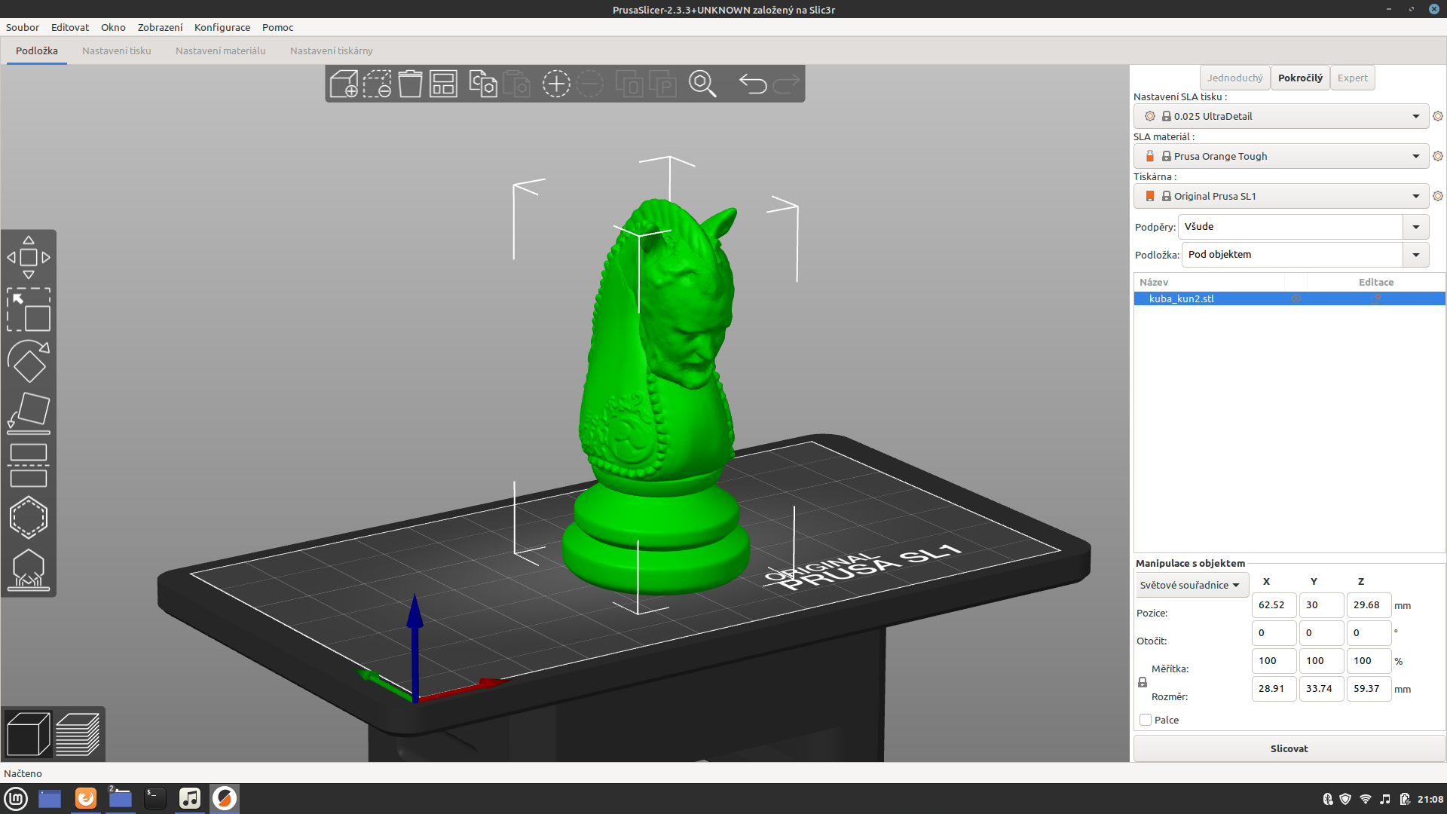
- creating a chessboard: Students struggled with the problem of solving the final form of a chessboard. The question arose as to what specific form the chessboard should have and how to technologically create it in such a way that it would be storable and that it would be possible to print the chessboard on a printer at the same time. The result is a collapsible chessboard made up of individual squares that fit together with the help of small locks. An unexpected advantage of this chessboard is that it can also be used by enthusiasts to create non-traditional forms of the chessboard.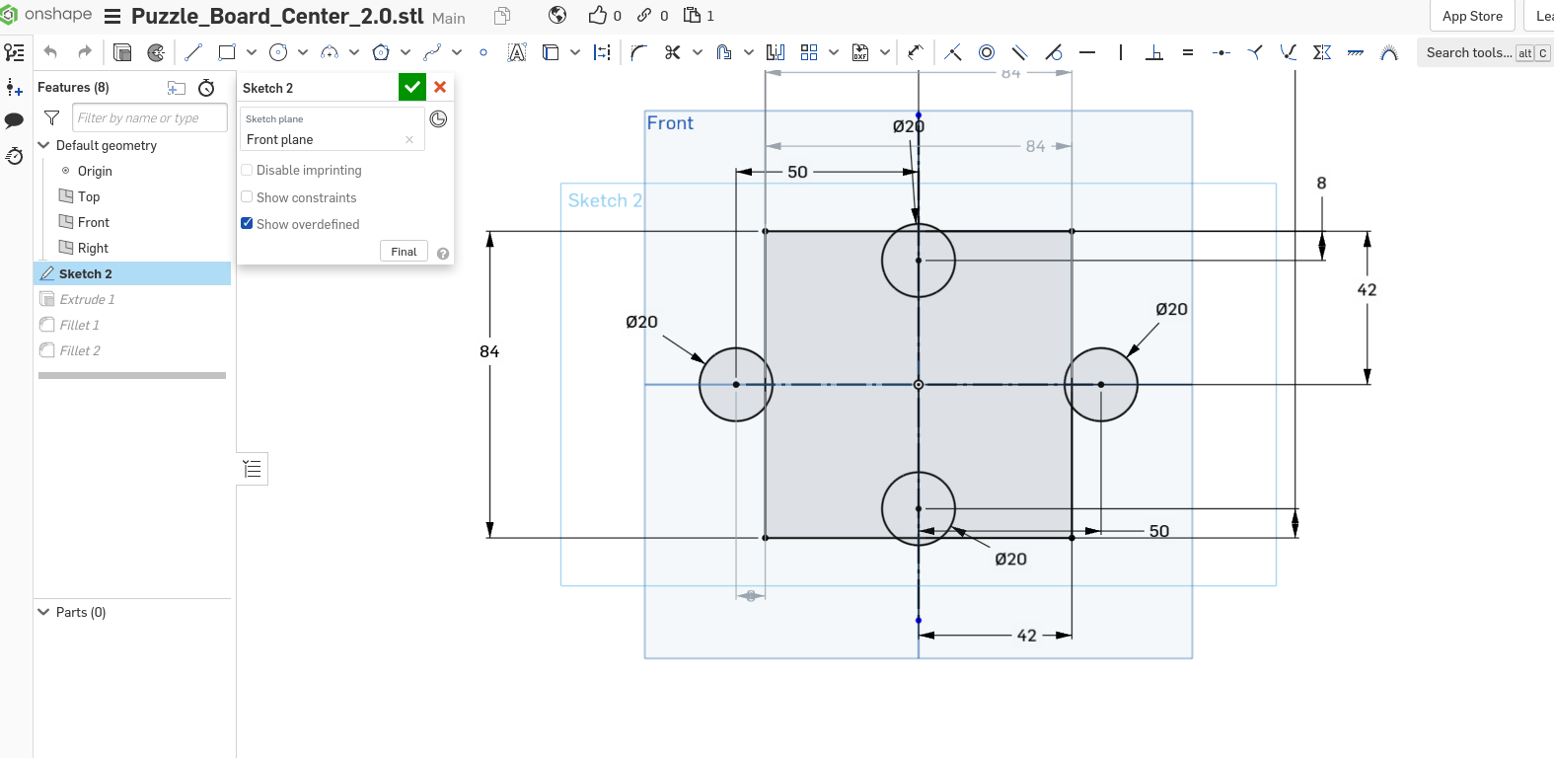
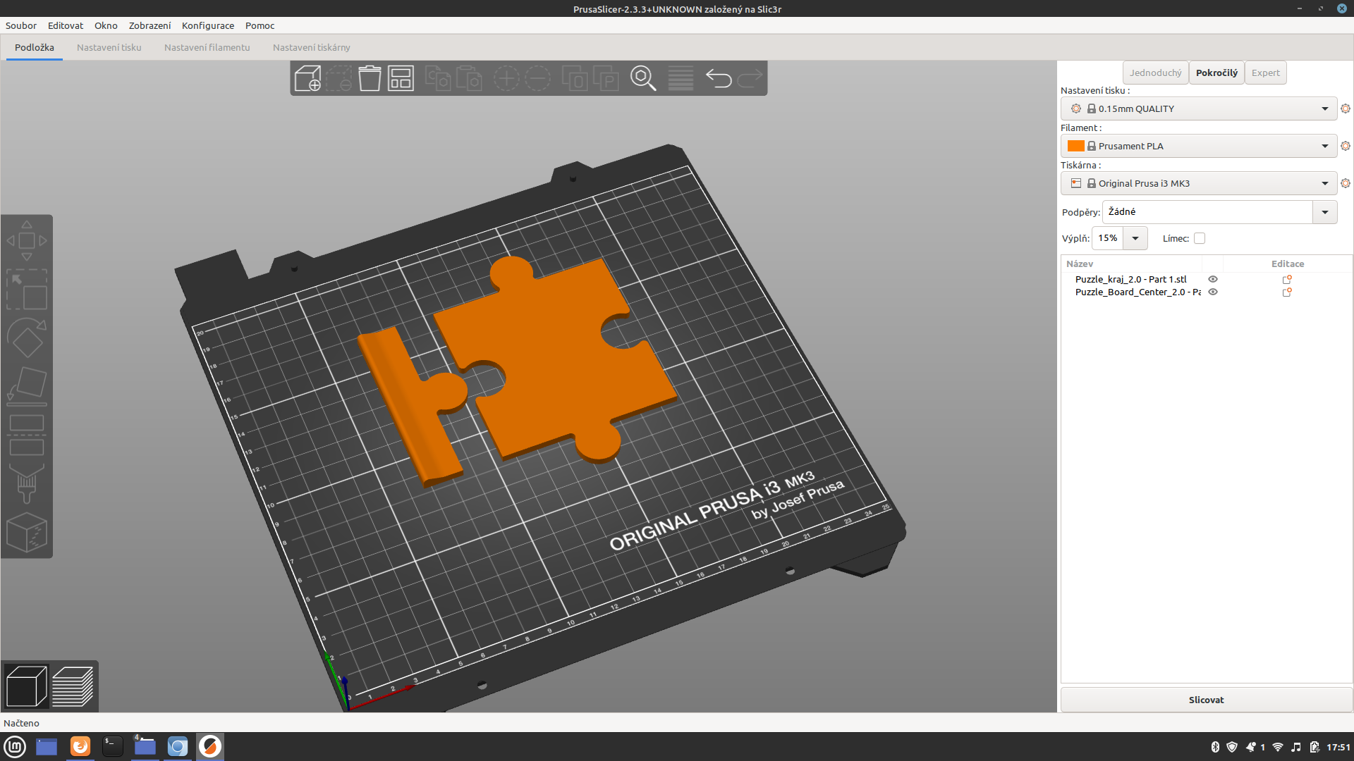
- Video tutorial: A video tutorial forms an imaginary container combined with a booklet. The individual moves of the figures are demonstrated using videos, which are linked by QR codes in the booklet
- booklet: The students structured the chess booklet as follows. In addition to general information about the "royal game", the individual figurines are presented using a specific language expression, which is based on the original nature of the figurines, e.g. the archer, originally a bishop, speaks to the reader of the brochure in a language imitating the liturgical language, etc. The second part of the page consists of vignettes of those that the figurines represent. Part of every interview with the people who served as a model is a mandatory answer to the question: What is your relationship to chess?
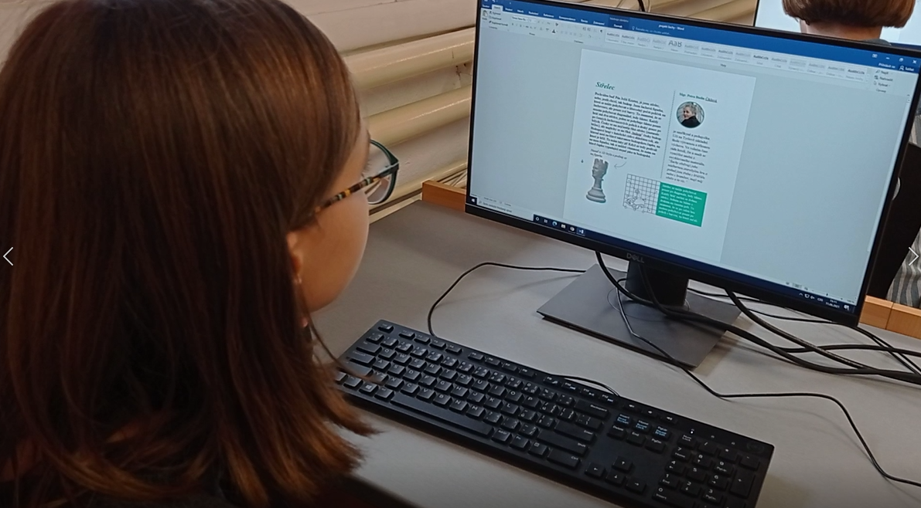
- graphic form of the brochure: When creating the graphic form, the pupils worked primarily with the Google Documents application, using text fields to create a simple graphic form. What makes the booklet different from the usual booklets for the game of chess is that the individual pages contain a 3D photo of the pieces, so with the help of 3D glasses, the piece "comes to life" for the reader in all its beauty even on paper.
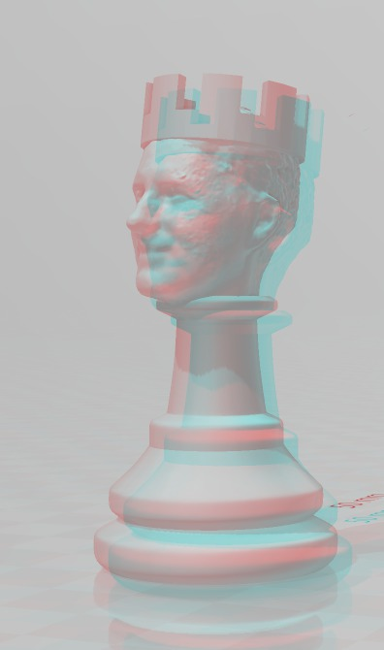

Detailed presentation of the encryption game part
The aim of this part: The main aim of this part was to introduce the pupils to the school building they are visiting in a non-traditional light through the encryption game. We wanted to try to break the everyday blindness that pupils and teachers have, because they perceive the details of the school building in everyday operation only subconsciously. It was the focus on detail through individual tasks that aimed to present the functionalist building, which is also a national cultural monument, in all its beauty and thoughtfulness.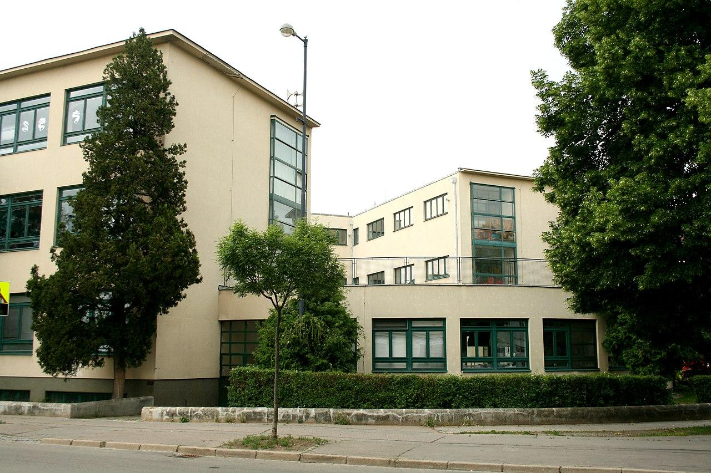
Encryption game: For the encryption game, it was necessary to create not only the framework of the game itself, but also to create a non-traditional system of rewards, invent tasks and above all, their interconnection and adaptability for long-term use. The game itself had a relatively long development, unexpected difficulties appeared in the process. It was a longer solution time and the big change in the team that caused this part to not be fully completed at the time of the presentation. Pupils solved these sub-steps one by one..
- Target group: Although the target group was clear from the beginning, i.e. primary school students, it became clear that the tasks in particular would have to be devised in such a way that they were not primarily based only on knowledge from individual subjects, as it was necessary to cover the availability and adequacy for the 3rd – 9th grade.
- Tasks: Initially, the teachers of individual subjects helped the students with the tasks, but the difficulty soon became apparent. This problem solution was that students can form teams across grades. In the end, most of the assignments were designed so that the subject knowledge was only a means to solve the given problem at the place where the assignment was given. I.e. so that students in teams perceive the place and with the help of architectural clues they solve the problem and not only through their knowledge.
- Reward system: The problem of how to motivate the students arose. This was finally solved by a reward system, which contains various rewards, e.g. not having to be on duty in the classroom, having priority in the lunch line etc. When devising the reward system, the sustainability and "maintenance-free" system turned out to be the biggest problem, with a number of rewards, there was also a problem of applying it with individual teachers. This problem was solved through chips printed on a 3D printer.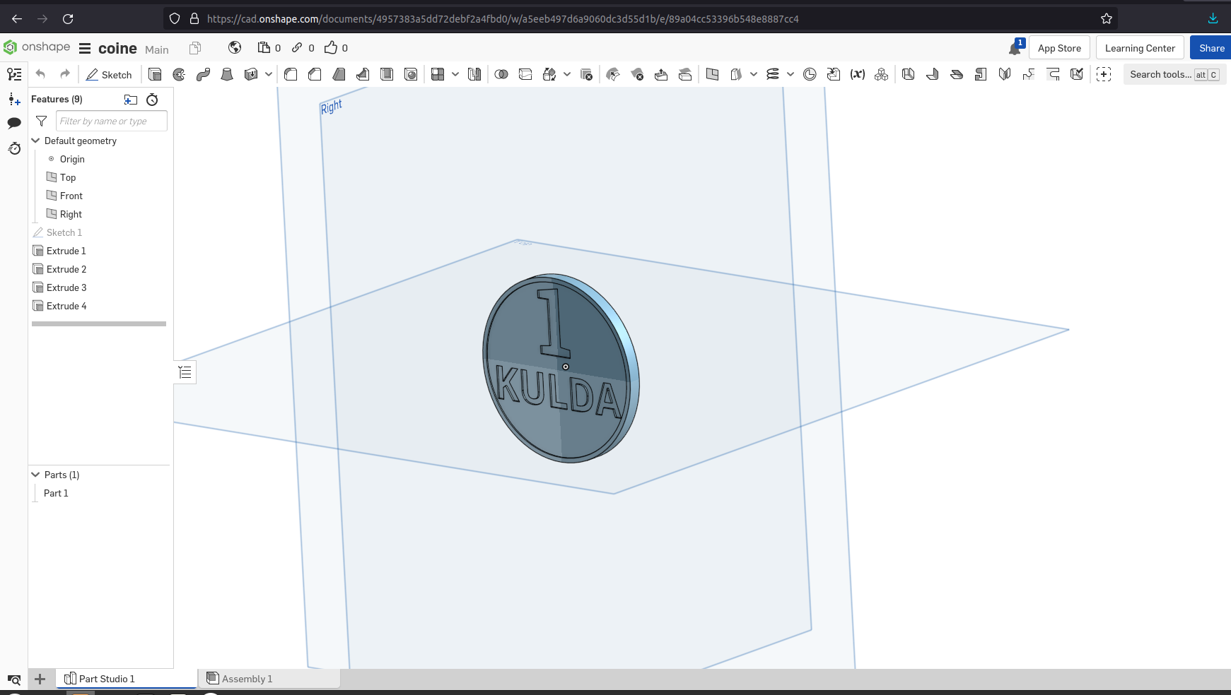
- Encryption system: The problem of the encryption system turned out to be one of the most difficult stages. It was mainly about preventing individual teams from solving one task at the same time. Therefore, a complex spider of passwords was created, which intertwined tasks in various combinations. So, although the groups solve the same tasks, they solve them at different times and in different order. For this part, a system of encrypted PDF files was chosen as the solution.
- Location of places: The school contains a number of interesting places, but the pupils found out very soon that individual places can be difficult to access and that many places are normally inaccessible to pupils. Therefore, according to the difficulty of the tasks, the individual places were chosen so that in the basic difficulty the students had complete freedom of movement around the places, in the case of the most difficult tasks, although the students got to interesting and unknown places in the school, they had to already have a supervisor with the keys to the given place. These places are located at the imaginary "top" and are designed so that students do not solve these tasks at once. However, the biggest obstacle turned out to be the question of changing places. In the case of location, over the years, students found out that many things in school are changeable, so some questions and locations had to be reworked three times.
- Robot: A programmed robot serves as a coin toss in this section. In addition to the rational element, we also wanted to introduce the principle of chance into this part. The robot is adapted to move along lines made of colored tapes and, using a sensor, drive along a designated track. At the end of the track there is an unspecified reward, so students can get a valuable reward thanks to the robot or, on the contrary, a totally worthless reward.
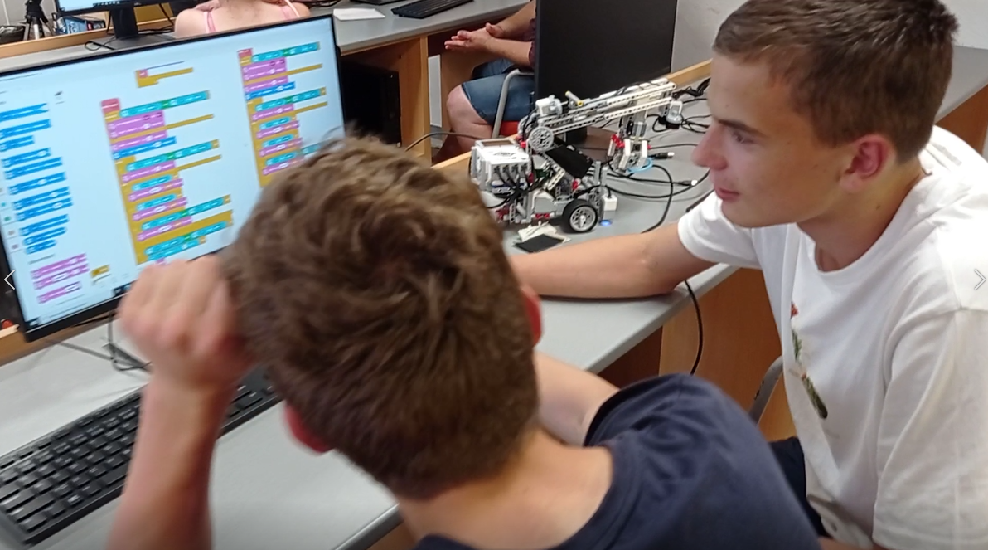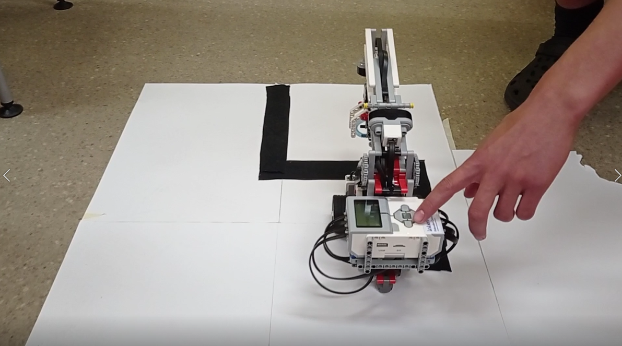

Theoretical basis
During the project, we had to study a large amount of documents. These were not classic publications, but a number of other, already implemented projects from which we drew inspiration and whose individual parts we adapted to our needs.
For the chess part of the project, we first of all needed to acquire knowledge in the field of chess literature, chess manuals and tutorials etc. were also used for the creation etc. For the final typesetting and the form of the brochure, we used a number of books from the school library as a "typesetting template". Tutorials and instructions also had to be studied for creating 3D models and for photographing individual characters.
For the encryption game part of the project, we used a wide range of dictionaries and encyclopaedias at the school, as well as books about Brno's functionalist architecture and findings from encryption games that had already been implemented. Tutorials from YouTube were once again used for programming the robot.

Examples of literature and sources:

BEDŘICHOVÁ, Jana a Stanislav HORNÝ. Počítačová typografie a sazba. Praha: Oeconomica, 2013. ISBN 978-80-245-1946-3.
DÍŽKA, Přemysl. Proměny století. IV, 150 historických a současných fotografií ze Židenic a Juliánova. Brno: Dížka, 2004. ISBN 80-239-3890-8.
NNES, Ali a Abbi CASTLE. Šachy pro každého. Brno: Extra Publishing, 2021. Jak na to. ISBN 978-80-7525-371-2.
KLOSKI, Liza Wallach a Nick KLOSKI. Začínáme s 3D tiskem. Brno: Computer Press, 2017. ISBN 978-80-251-4876-1.
PECINA, Martin. Knihy a typografie. Vydání třetí, rozšířené. Brno: Host, 2017. ISBN 978-80-7577-040-0.
RYŠAVÝ, Šimon. Kulturní průvodce po MČ Brno-Židenice - kulturní stezka: Židenice k.ú. Židenice 215 m. Brno: Šimon Ryšavý, 2011. ISBN 978-80-7354-096-8.
VALDHANSOVÁ, Lucie. Co je Brno?: funkcionalismus. Brno: TIC Brno, 2018.
ZAPLETAL, Miloš. Špalíček her. Praha: Albatros, 1988.
ZAPLETAL, Miloš. Rádce skautské družiny. Vydání třetí. Praha: Junák - český skaut, Tiskové a distribuční centrum, 2016. ISBN 978-80-7501-102-2.

FOGLAR, Jaroslav a Miloš ZAPLETAL. Hry Jaroslava Foglara. Praha: Olympia, 2000. Sebrané spisy Jaroslava Foglara. ISBN 80-7033-680-3.

Examples of encryption games:

https://www.tmou.cz/
https://stisk.online/a/SQDL9/naucna-stezka-ukazuje-lidem-brnenske-povesti
https://trails.cryptomania.cz/

Materials for working with students (examples):
ČAPEK, Robert. Moderní didaktika: lexikon výukových a hodnoticích metod. Praha: Grada, 2015. Pedagogika. ISBN 978-80-247-3450-7.
ČAPEK, Robert. Uč jako umělec: malá kniha o velkých vzdělávacích myšlenkách. V Brně: Jan Melvil Publishing, 2020. Briquet. ISBN 978-80-7555-105-4.
KRATOCHVÍLOVÁ, Jana. Teorie a praxe projektové výuky. 2. vydání. Brno: Masarykova univerzita, 2016. ISBN 978-80-210-8163-5.
Programování (nejen) v mezinárodních projektech: aktivity do výuky. Praha: Dům zahraniční spolupráce (DZS), 2020. ISBN 978-80-88153-78-8.
SIEGLOVÁ, Dagmar. Konec školní nudy: didaktické metody pro 21. století. Praha: Grada, 2019. ISBN 978-80-271-2254-7.
SVOBODOVÁ, Anna, Marek EHRLICH a Kateřina KADEŘÁBKOVÁ VITOCHOVÁ. Objevujeme krajinu společně s památkáři: katalog výstavy k projektu Identifikace a prezentace památkového potenciálu historické kulturní krajiny České republiky. České Budějovice: Národní památkový ústav, územní odborné pracoviště v Českých Budějovicích, 2020. ISBN 978-80-85033-92-2.

Project benefits
The benefits of the project can be divided into several categories.
- Intersubject relationships
The project developed cross-subject relationships and, above all, the need to apply the knowledge gained during basic education in practice for the pupils who participated in its implementation. Knowledge gained in English, computer science, history, natural history, civics and other subjects.
- Competence to solve problems.
In the case of the project, as already mentioned, a number of problems arose, the solution of which required not only technical knowledge and knowledge from many fields, but also the need to use and develop a number of soft skills such as competence to solve problems, communication skills, working in a team, working with an opinion, etc.
- Social outreach and school climate improvement
During the project, pupils from across grades who needed to work together met as part of the collaboration, friendships between pupils across grades were often formed in this way, in addition, many pupils from different grades discovered that they cooperated very well together, so they decided to participate in other extracurricular activities in similar teams
- Pupils for pupils
Applying their knowledge, the students created a number of things as a by-product of these two parts of the project, which proved to be suitable as teaching aids for lower grades. E.g. The booklet was used in computer science classes as an aid for teaching typography, photography was also reflected in art education classes, the game throughout the school creates space for applying knowledge from other subjects.
- The place where we live
The impact of the project was also reflected in the school's students getting to know the place where they spend a significant part of their day better. The project helped the pupils to make contact with the work of the functionalist architect Oskar Pořízka.
- Cooperation with other entities
The knowledge of the pupils in the project was shared with other entities. E.g. knowledge in the field of architecture, which related to the school building, immediately found a double application, on one hand during the presentation of the school as part of the Brno Open Houses project (https://www.youtube.com/watch?v=COY_RJntmTc) , on the other hand when presenting the school building to the general public as part of the „Překročme řeku“ festival (https://www.facebook.com/events/n%C3%A1b%C5%99e%C5%BE%C3%AD-svitavy/p%C5%99ekro%C4%8Dme-%C5%99eku-2021-festival-na-n%C3%A1b%C5%99e%C5%BE%C3%AD/902351080344806/). The creation of chess using 3D printing, on the other hand, helped to establish cooperation with Mendel University, specifically with a PhD student in the field of Landscape Architecture Ing. Dan Šamánek, who shared his knowledge with our students and at the same time used the students' knowledge in the field of photogrammetry and 3D printing in the creation of 3D models of Ignaz Lengerlacher's sculptures in Slavkov near Brno (https://sketchfab.com/dansamanek/collections/austerlitz-slavkov-u-brna)
- The results of the pupils' work were also presented on the school's Instagram and on the school's website

Project summary
The project was beneficial in all respects. In the future, we would like to continue participating in similar projects, hopefully in more favourable times. The main weakness of the project turned out to be the long time horizon, which caused a "fluctuation" of pupils and also the fact that, as the project was very dependent on the pupils completing individual sub-phases at school, it was not possible to work consistently in some parts. Nevertheless, even if we did not have time to finalise the second part, the students want to finish the second part even beyond the time frame of the project. A big advantage of the project is that the students will be left with a permanent result in the school, which puts everyday work in the school in a completely different light. The project showed that students can apply their knowledge from individual subjects in practice and transform their knowledge into a tangible result. Among other things, this also created a strong bond between the graduates and the school, because the former ninth graders who have already left for secondary schools still communicate with their younger classmates about the project and are keenly interested in the project. In addition, the pupils enjoyed working with new technologies and presenting their outputs to a wider public. The project also proved to be very beneficial from the point of view of communication, as part of the project the pupils tried a different kind of communication with the teachers, who in certain phases became the pupils' collaborators and co-solvers of individual parts. Last but not least, the group of pupils that emerged during the work created an active core of pupils, which gradually "rounded up" other pupils who decided to participate in other projects. Overall, the project can be evaluated very positively. It is also necessary to add that the students look forward to the presentation of the projects themselves, in order to be inspired by other projects and the creations and outputs of students from other schools. Even this connection appears to be important and very useful in the future.

